哈尔滨工业大学计算学部
实验报告

课程名称：数据结构与算法
课程类型：专业核心基础课（必修）
实验项目：图型结构及其应用
实验题目：最短路径算法
实验日期：2023/10/25

班级：2203101
学号：2022113573
姓名：张宇杰

设计成绩 | 报告成绩 | 指导老师
 |  | 张岩

一、实验目的
最短路径问题研究的主要有：单源最短路径问题和所有顶点对之间的最短路径问题。在计算机领域和实际工程中具有广泛的应用，如集成电路设计、GPS/游戏地图导航、智能交通、路由选择、铺设管线等。本实验要求设计和实现 Dijkstra算法和 Floyd-Warshall 算法，求解最短路径问题。
二、实验要求及实验环境
实验要求：
1．实现单源最短路径的Dijkstra算法，输出源点及其到其他顶点的最短路径长度和最短路径
2．实现全局最短路径的Floyd-Warshall算法。计算任意两个顶点间的最短距离矩阵和最短路径矩阵，并输出任意两个顶点间的最短路径长度和最短路径
3．利用Dijkstra或Floyd-Warshall算法解决单目标最短路径问题：找出图中每个顶点v到某个指定顶点c最短路径
4．利用Dijkstra或Floyd-Warshall算法解决单顶点对间最短路径问题：对于某对顶点u和v，找出u到v和v到u的一条最短路径
5．以文件形式输入图的顶点和边，并以适当的方式展示相应的结果。要求顶点不少于10个，边不少于13个
6．选做：实现Warshall算法，计算有向图的可达矩阵，理解可达矩阵的含义
7．选做：利用堆结构（优先级队列）改进和优化Dijkstra算法，实现改进和优化的Dijkstra算法，并与原算法进行实验比较
实验环境：
Windows 11, g++, gdb, VS2022
三、设计思想（本程序中的用到的所有数据类型的定义，主程序的流程图及各程序模块之间的调用关系、核心算法的主要步骤）
1．逻辑设计
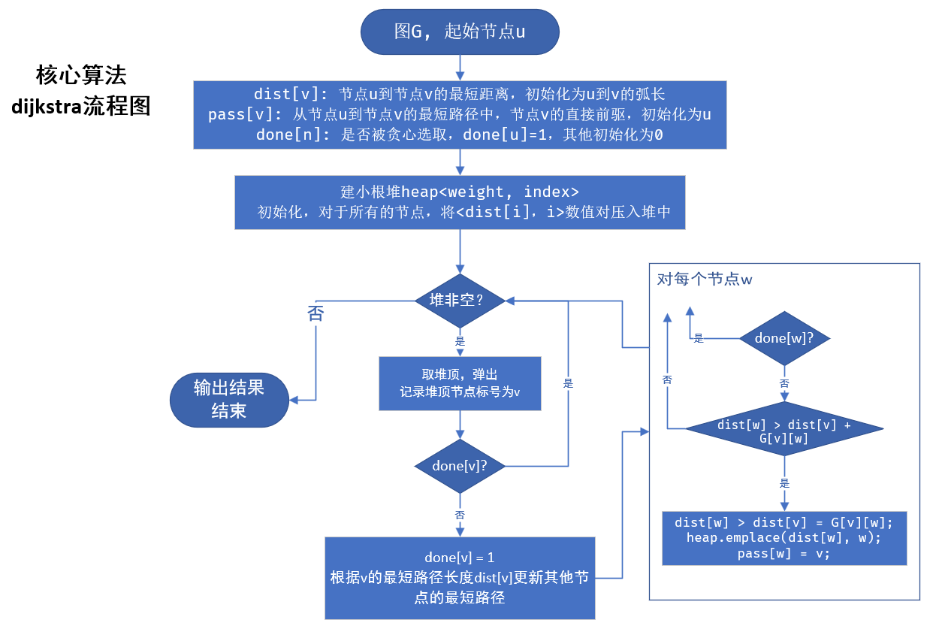
floyd本身太简单了就没画了
2．物理设计（即存储结构设计）
使用自定义类AdjacencyMatrixGraph
使用STL容器vector, stack, priority_queue
所有算法函数原型如下：
- namespace MyGraph {

- void dijkstra(const AdjacencyMatrixGraph& G, label label_from, ::std::ostream& out_dest = ::std::cout);

- void __dijkstra(const AdjacencyMatrixGraph& G, index u, ::std::vector<weight>& dist, ::std::vector<index>& pass);

- void __dijkstra_show_path(const AdjacencyMatrixGraph& G, index u, index v, ::std::vector<weight>& dist, ::std::vector<index>& pass, ::std::ostream& out_dest);

- void floyd(const AdjacencyMatrixGraph& G, ::std::ostream& out_dest = ::std::cout);

- void warshall(const AdjacencyMatrixGraph& G, ::std::ostream& out_dest = ::std::cout);

- void all_shortest_to(const AdjacencyMatrixGraph& G, label label_to, ::std::ostream& out_dest = ::std::cout);

- void shortest_pair(const AdjacencyMatrixGraph& G, label label_from, label label_to, ::std::ostream& out_dest = ::std::cout);

- } // namespace MyGraph
自定义数据类型AdjacencyMatrixGraph的定义
- class AdjacencyMatrixGraph: public Graph<matrixAdjIter> {

- friend class matrixAdjIter;
- friend AdjacencyListGraph matrixToList(const AdjacencyMatrixGraph& G);
- friend AdjacencyMatrixGraph listToMatrix(const AdjacencyListGraph& G);

- public:
- using adjIterator = matrixAdjIter;

- private:
- using matrix = ::std::vector<::std::vector<weight>>;
- matrix m_matrix;

- static constexpr int initialMatrixSize = 20;
- static constexpr int extendMatrixSize = 5;

- private:
- void extendMatrix();

- public:
- AdjacencyMatrixGraph();

- virtual void addVertex(label vertex_add);

- virtual void addEdge(index vertex_from, index vertex_to, weight w) noexcept;

- virtual weight getEdgeWeight(index vertex_from, index vertex_to) const noexcept;

- virtual void removeVertex(index vertex_index) noexcept;

- virtual void removeEdge(index vertex_from, index vertex_to) noexcept;

- virtual adjIterator beginAdjacentIterOf(index idx);

- virtual adjIterator endAdjacentIterOf(index idx);

- void showMatrix(::std::ostream& out = ::std::cout) const;

- }; // class AdjacencyMatrixGraph

四、测试结果（包括测试数据、结果数据及结果的简单分析和结论，可以用截图得形式贴入此报告）
以下语境中的图1(graph_1)指：
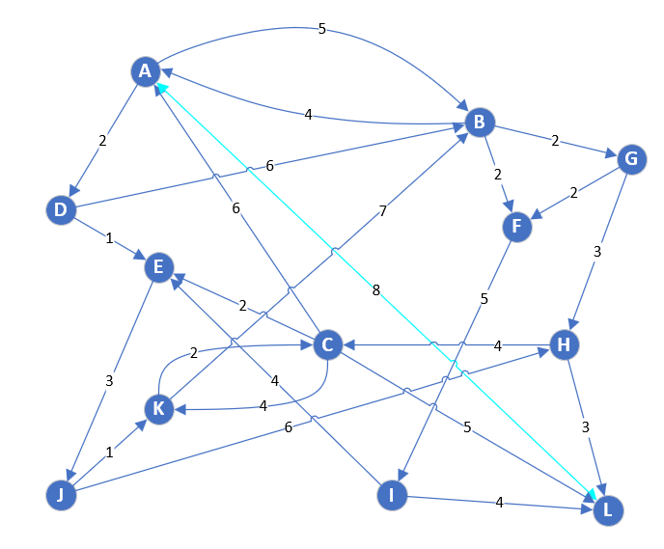
图2(graph_2)指：
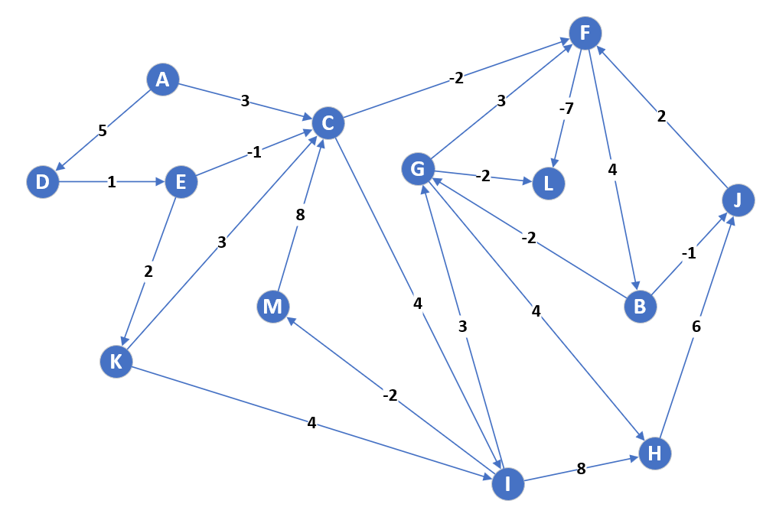
1．实现单源最短路径的Dijkstra算法，输出源点及其到其他顶点的最短路径长度和最短路径
运行程序：
- #include <iostream>
- #include <fstream>

- #include ".\src\header\MyGraph"
- #include ".\src\ShortestPathAlgorithm"
- using namespace MyGraph;
- using namespace std;

- int main()
- {
- system("chcp 65001"); // set terminal to UTF-8 mode, for showing Chinese characters currectly
- ifstream command("./graph_1.txt");

- AdjacencyMatrixGraph G1;
- G1.commandSequence(command);

- dijkstra(G1, "B");

- return 0;
- }
输出结果：
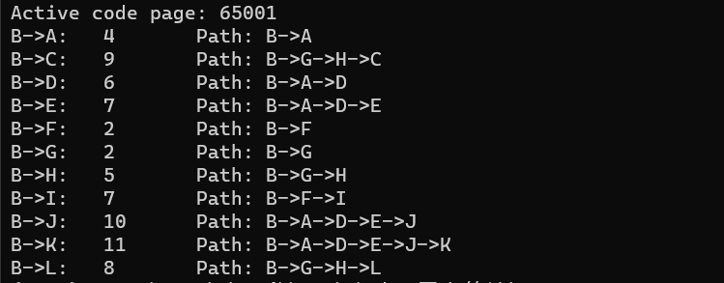
结果正确

2．实现全局最短路径的Floyd-Warshall算法。计算任意两个顶点间的最短距离矩阵和最短路径矩阵，并输出任意两个顶点间的最短路径长度和最短路径
输入程序：
- #include <iostream>
- #include <fstream>

- #include ".\src\header\MyGraph"
- #include ".\src\ShortestPathAlgorithm"
- using namespace MyGraph;
- using namespace std;

- int main()
- {
- system("chcp 65001"); // set terminal to UTF-8 mode, for showing Chinese characters currectly
- ifstream command("./graph_2.txt");

- AdjacencyMatrixGraph G2;
- G2.commandSequence(command);

- floyd(G2);

- return 0;
- }

输出结果：
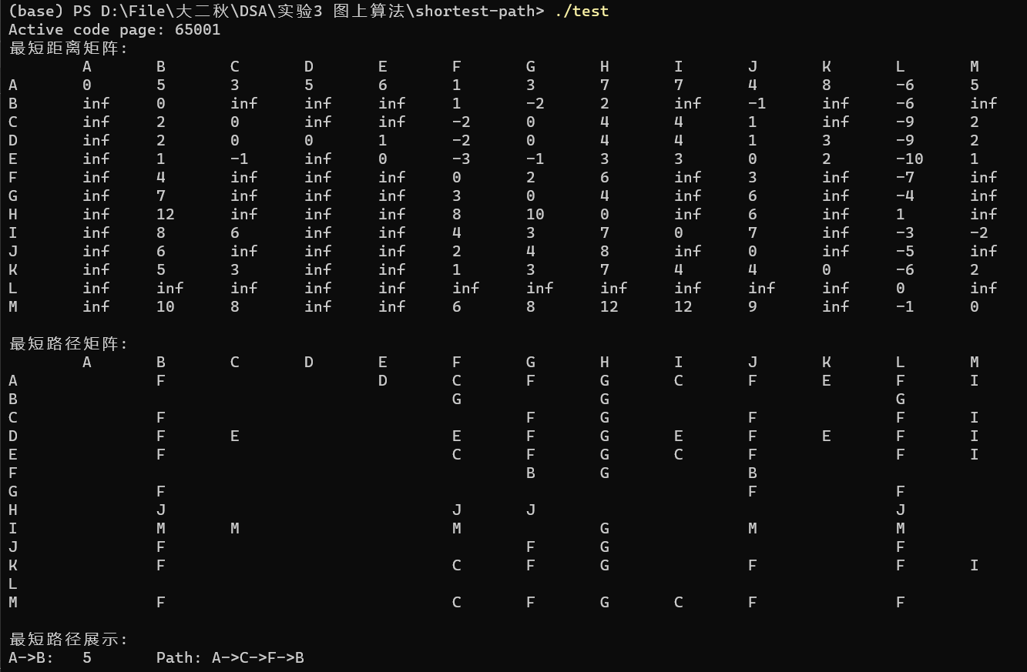
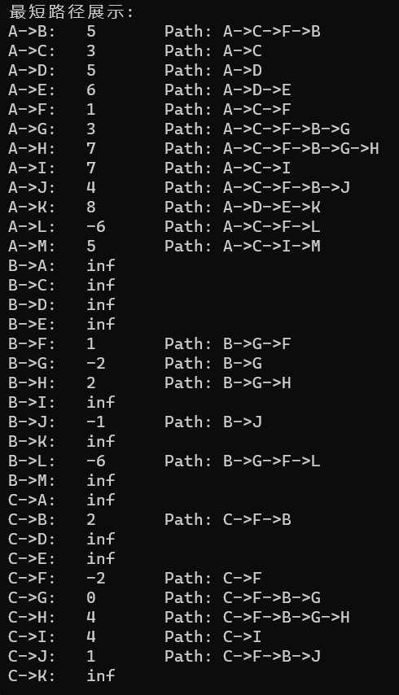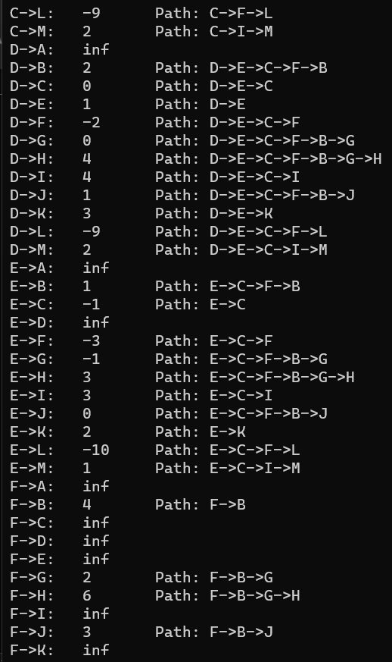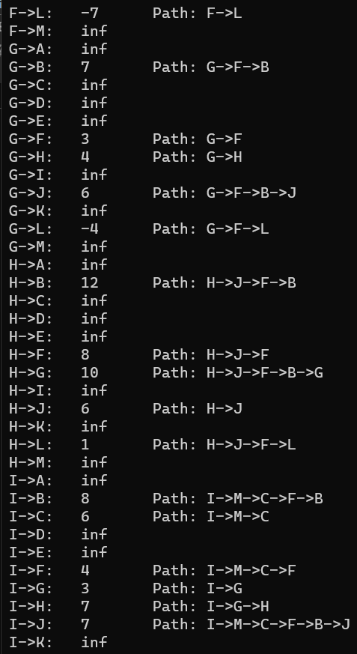
输出符合预期

3．利用Dijkstra或Floyd-Warshall算法解决单目标最短路径问题：找出图中每个顶点v到某个指定顶点c最短路径

运行程序：
- #include <iostream>
- #include <fstream>

- #include ".\src\header\MyGraph"
- #include ".\src\ShortestPathAlgorithm"
- using namespace MyGraph;
- using namespace std;

- int main()
- {
- system("chcp 65001"); // set terminal to UTF-8 mode, for showing Chinese characters currectly
- ifstream command("./graph_1.txt");

- AdjacencyMatrixGraph G1;
- G1.commandSequence(command);

- all_shortest_to(G1, "F");

- return 0;
- }
输出结果：
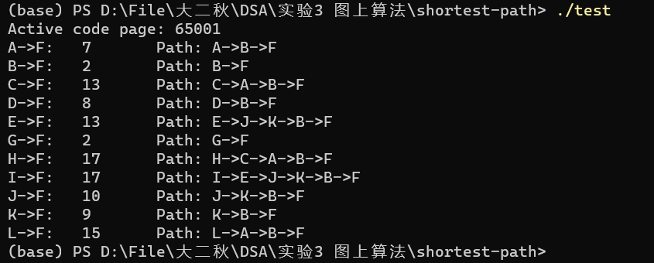
结果正确

4．利用Dijkstra或Floyd-Warshall算法解决单顶点对间最短路径问题：对于某对顶点u和v，找出u到v和v到u的一条最短路径

运行程序：
- #include <iostream>
- #include <fstream>

- #include ".\src\header\MyGraph"
- #include ".\src\ShortestPathAlgorithm"
- using namespace MyGraph;
- using namespace std;

- int main()
- {
- system("chcp 65001"); // set terminal to UTF-8 mode, for showing Chinese characters currectly
- ifstream command("./graph_1.txt");

- AdjacencyMatrixGraph G1;
- G1.commandSequence(command);

- shortest_pair(G1, "F", "C");

- return 0;
- }
输出结果：
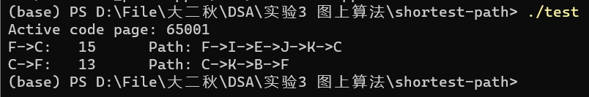
符合预期
五、经验体会与不足
体会：巩固了各类最短路径算法的实现
不足：使用邻接矩阵作为图的数据结构，以上算法未对邻接表数据结构进行实现
六、附录：源代码（带注释）
ShortestPathAlgorithm.h
- #ifndef _SHORTEST_PATH_ALGORITHM_H_INCLUDED_
- #define _SHORTEST_PATH_ALGORITHM_H_INCLUDED_

- #include <iostream>
- #include "./header/MyGraph"

- namespace MyGraph {

- void dijkstra(const AdjacencyMatrixGraph& G, label label_from, ::std::ostream& out_dest = ::std::cout);

- void __dijkstra(const AdjacencyMatrixGraph& G, index u, ::std::vector<weight>& dist, ::std::vector<index>& pass);

- void __dijkstra_show_path(const AdjacencyMatrixGraph& G, index u, index v, ::std::vector<weight>& dist, ::std::vector<index>& pass, ::std::ostream& out_dest);

- void floyd(const AdjacencyMatrixGraph& G, ::std::ostream& out_dest = ::std::cout);

- void warshall(const AdjacencyMatrixGraph& G, ::std::ostream& out_dest = ::std::cout);

- void all_shortest_to(const AdjacencyMatrixGraph& G, label label_to, ::std::ostream& out_dest = ::std::cout);

- void shortest_pair(const AdjacencyMatrixGraph& G, label label_from, label label_to, ::std::ostream& out_dest = ::std::cout);

- } // namespace MyGraph

- #endif // _SHORTEST_PATH_ALGORITHM_H_INCLUDED_
dijkstra.cpp
- #include "ShortestPathAlgorithm.h"

- #include <vector>
- #include <stack>
- #include <queue>

- void MyGraph::__dijkstra(const AdjacencyMatrixGraph& G, index u, ::std::vector<weight>& dist, ::std::vector<index>& pass) {
- using namespace std;

- // dist[v]: 节点u到节点v的最短路径长度
- // pass[v]: 从节点u到节点v的最短路径中，节点v的直接前驱

- size n = G.countVertex(); // 图的顶点数

- vector<char> done(n, 0); // done[u]: 节点是否被贪心选取

- using pair = pair<weight, index>;
- priority_queue<pair, vector<pair>, greater<pair>> heap; // 小根堆，对dijkstra算法的优化

- // ***** 初始化工作 *****
- for (index v = 0; v < n; ++v) {
- dist.at(v) = G.getEdgeWeight(u, v); // dist数组初始化为u至v的弧长
- pass.at(v) = u;
- heap.emplace(dist.at(v), v); // 将<权值，标号>数值对压入堆中，将自动将这些数值对按照weight优先，index其次进行排序
- }
- done.at(u) = 1; // 显然u已经完成计算

- while (!heap.empty()) {
- pair p = heap.top(); // 取出堆顶
- heap.pop();

- index v = p.second; // 当前未选取的节点中节点u到其距离最短的那个节点

- if (done.at(v)) // 如果已经被贪心选取
- continue; // 抛弃这个节点
- else {
- done.at(v) = 1;

- for (index w = 0; w < n; ++w) // 通过这个贪心选取的节点，去更新其他节点最短路径
- if (!done.at(w))
- if (dist.at(w) > dist.at(v) + G.getEdgeWeight(v, w)) {
- dist.at(w) = dist.at(v) + G.getEdgeWeight(v, w);
- heap.emplace(dist.at(w), w);
- pass.at(w) = v;
- }
- }
- }
- }

- void MyGraph::__dijkstra_show_path(const AdjacencyMatrixGraph& G, index u, index v, ::std::vector<weight>& dist, ::std::vector<index>& pass, ::std::ostream& out_dest) {
- using namespace std;

- static stack<index> st; // 栈，用于输出路径

- if (v == u)
- return;

- out_dest << G.getLabel(u) << "->" << G.getLabel(v) << ":\t";
- if (dist.at(v) >= infinity) {
- out_dest << "inf" << endl; // 不可达
- return;
- }
- else
- out_dest << dist.at(v) << "\tPath: "; // 可达，先输出路径长度，再输出路径

- index i = v;
- while (i != u) {
- st.push(i);
- i = pass.at(i);
- }

- out_dest << G.getLabel(u);
- while (!st.empty()) {
- out_dest << "->" << G.getLabel(st.top());
- st.pop();
- }

- out_dest << endl;
- }

- void MyGraph::dijkstra(const AdjacencyMatrixGraph& G, label label_from, ::std::ostream& out_dest) {
- using namespace std;

- if (!G.isVertex(label_from)) {
- cout << "Invalid label" << endl;
- return;
- }

- size n = G.countVertex(); // 图的顶点数
- index u = G.getIndex(label_from); // 起点的编号u

- vector<weight> dist(n); // dist[v]: 节点u到节点v的最短路径长度
- vector<index> pass(n); // pass[v]: 从节点u到节点v的最短路径中，节点v的直接前驱

- __dijkstra(G, u, dist, pass);

- // ***** 结果展示 *****
- stack<index> st; // 栈，用于输出路径

- for (index v = 0; v < n; ++v) // 对每个节点，输出节点u到其的最短路径
- __dijkstra_show_path(G, u, v, dist, pass, cout);
- }
floyd.cpp
- #include "ShortestPathAlgorithm.h"

- #include <vector>

- void __show_path(const ::MyGraph::AdjacencyMatrixGraph& G, ::std::vector<::std::vector<::MyGraph::index>>& pass, ::MyGraph::index u, ::MyGraph::index v) {
- using namespace std;
- using namespace MyGraph;

- index k = pass[u][v];

- if (k != -1) {
- __show_path(G, pass, u, k);
- cout << G.getLabel(k) << "->";
- __show_path(G, pass, k, v);
- }
- }

- void MyGraph::floyd(const AdjacencyMatrixGraph& G, ::std::ostream& out_dest) {
- using namespace std;

- size n = G.countVertex(); // 图的顶点数

- vector<vector<weight>> dist(n, vector<weight>(n, 0)); // dist[u][v]: u到v的最短距离
- vector<vector<index>> pass(n, vector<index>(n, -1)); // pass[u][v]: u到v的路径中包含的点, -1为没有包含

- for (index i = 0; i < n; ++i) // 初始化距离矩阵
- for (index j = 0; j < n; ++j) {
- if (i == j)
- dist[i][j] = 0;
- else
- dist[i][j] = G.getEdgeWeight(i, j);
- }

- // floyd算法核心
- for (index k = 0; k < n; ++k)
- for (index i = 0; i < n; ++i)
- for (index j = 0; j < n; ++j)
- if (dist[i][j] > dist[i][k] + dist[k][j] && dist[i][k] < infinity && dist[k][j] < infinity) { // 动态规划
- dist[i][j] = dist[i][k] + dist[k][j];
- pass[i][j] = k;
- }

- // ***** 结果展示 *****

- out_dest << "最短距离矩阵:" << endl;
- for (index i = 0; i < n; ++i)
- out_dest << '\t' << G.getLabel(i);
- out_dest << endl;

- for (index i = 0; i < n; ++i) {
- out_dest << G.getLabel(i) << '\t';

- for (index j = 0; j < n; ++j)
- if (dist[i][j] >= infinity)
- out_dest << "inf" << '\t';
- else
- out_dest << dist[i][j] << '\t';

- out_dest << endl;
- }
- out_dest << endl;

- out_dest << "最短路径矩阵:" << endl;
- for (index i = 0; i < n; ++i)
- out_dest << '\t' << G.getLabel(i);
- out_dest << endl;

- for (index i = 0; i < n; ++i) {
- out_dest << G.getLabel(i) << '\t';

- for (index j = 0; j < n; ++j)
- out_dest << G.getLabel(pass[i][j]) << '\t';

- out_dest << endl;
- }
- out_dest << endl;

- out_dest << "最短路径展示:" << endl;
- for (index i = 0; i < n; ++i) // 对任意两个不相同的节点，都输出二者之间的最短路径
- for (index j = 0; j < n; ++j) {
- if (i == j)
- continue;

- out_dest << G.getLabel(i) << "->" << G.getLabel(j) << ":\t";
- if (dist[i][j] >= infinity)
- out_dest << "inf" << endl; // 不可达
- else {
- out_dest << dist[i][j] << "\tPath: " << G.getLabel(i) << "->";
- __show_path(G, pass, i, j);
- out_dest << G.getLabel(j) << endl;
- }
- }
- }
warshall.cpp
- #include "ShortestPathAlgorithm.h"

- #include <vector>

- void MyGraph::warshall(const AdjacencyMatrixGraph& G, ::std::ostream& out_dest) {
- using namespace std;

- size n = G.countVertex(); // 图的顶点数

- vector<vector<char>> reachable(n, vector<char>(n, 0)); // dist[u][v]: u到v的最短距离

- for (index i = 0; i < n; ++i)
- for (index j = 0; j < n; ++j) {
- if (i == j)
- reachable[i][j] = 1;
- else
- reachable[i][j] = G.getEdgeWeight(i, j) >= infinity ? 0 : 1;
- }

- for (index k = 0; k < n; ++k)
- for (index i = 0; i < n; ++i)
- for (index j = 0; j < n; ++j)
- reachable[i][j] |= reachable[i][k] & reachable[k][j];

- // *****结果展示*****

- out_dest << "可达矩阵:" << endl;
- for (index i = 0; i < n; ++i)
- out_dest << '\t' << G.getLabel(i);
- out_dest << endl;

- for (index i = 0; i < n; ++i) {
- out_dest << G.getLabel(i) << '\t';

- for (index j = 0; j < n; ++j)
- out_dest << reachable[i][j] + 0 << '\t';

- out_dest << endl;
- }
- }
all_shortest_to.cpp
- #include "ShortestPathAlgorithm.h"

- #include <vector>
- #include <queue>

- void MyGraph::all_shortest_to(const AdjacencyMatrixGraph& G, label label_to, ::std::ostream& out_dest) {
- using namespace std;

- if (!G.isVertex(label_to)) {
- cout << "Invalid label" << endl;
- return;
- }

- size n = G.countVertex(); // 图的顶点数
- index v = G.getIndex(label_to); // 终点的编号u

- vector<weight> dist(n); // dist[v]: 节点u到节点v的最短路径
- vector<index> pass(n); // pass[v]: 从节点u到节点v的最短路径中，节点v的直接前驱

- AdjacencyMatrixGraph G_T; // 图G的转置

- // 求G的转置
- for (index i = 0; i < n; ++i)
- G_T.addVertex(G.getLabel(i));
- for (index i = 0; i < n; ++i)
- for (index j = 0; j < n; ++j)
- if (G.isEdge(i, j))
- G_T.addEdge(j, i, G.getEdgeWeight(i, j));

- __dijkstra(G_T, v, dist, pass);

- // *****结果展示*****
- for (index u = 0; u < n; ++u) {
- if (v == u)
- continue;

- out_dest << G.getLabel(u) << "->" << label_to << ":\t";
- if (dist.at(u) >= infinity) {
- out_dest << "inf" << endl;
- continue;
- }
- else
- out_dest << dist.at(u) << "\tPath: ";

- index i = u;
- while (i != v) {
- out_dest << G.getLabel(i) << "->";
- i = pass.at(i);
- }
- out_dest << label_to << endl;
- }
- }
shortest_pair.cpp
- #include "ShortestPathAlgorithm.h"

- #include <vector>

- void MyGraph::shortest_pair(const AdjacencyMatrixGraph& G, label label_from, label label_to, ::std::ostream& out_dest) {
- using namespace std;

- if (!G.isVertex(label_from) || !G.isVertex(label_to) || label_from == label_to) {
- cout << "Invalid label" << endl;
- return;
- }

- size n = G.countVertex(); // 图的顶点数
- index u = G.getIndex(label_from), v = G.getIndex(label_to);

- vector<weight> dist_u_to(n), dist_v_to(n);
- vector<index> pass_u_to(n), pass_v_to(n);

- // 使用两次dijkstra算法，求出u到v的最短路径，以及v到u的最短路径
- __dijkstra(G, u, dist_u_to, pass_u_to);
- __dijkstra(G, v, dist_v_to, pass_v_to);

- // ***** 结果展示 *****

- // 输出u到v的路径
- __dijkstra_show_path(G, u, v, dist_u_to, pass_u_to, cout);

- // 输出v到u的路径
- __dijkstra_show_path(G, v, u, dist_v_to, pass_v_to, cout);
- }

